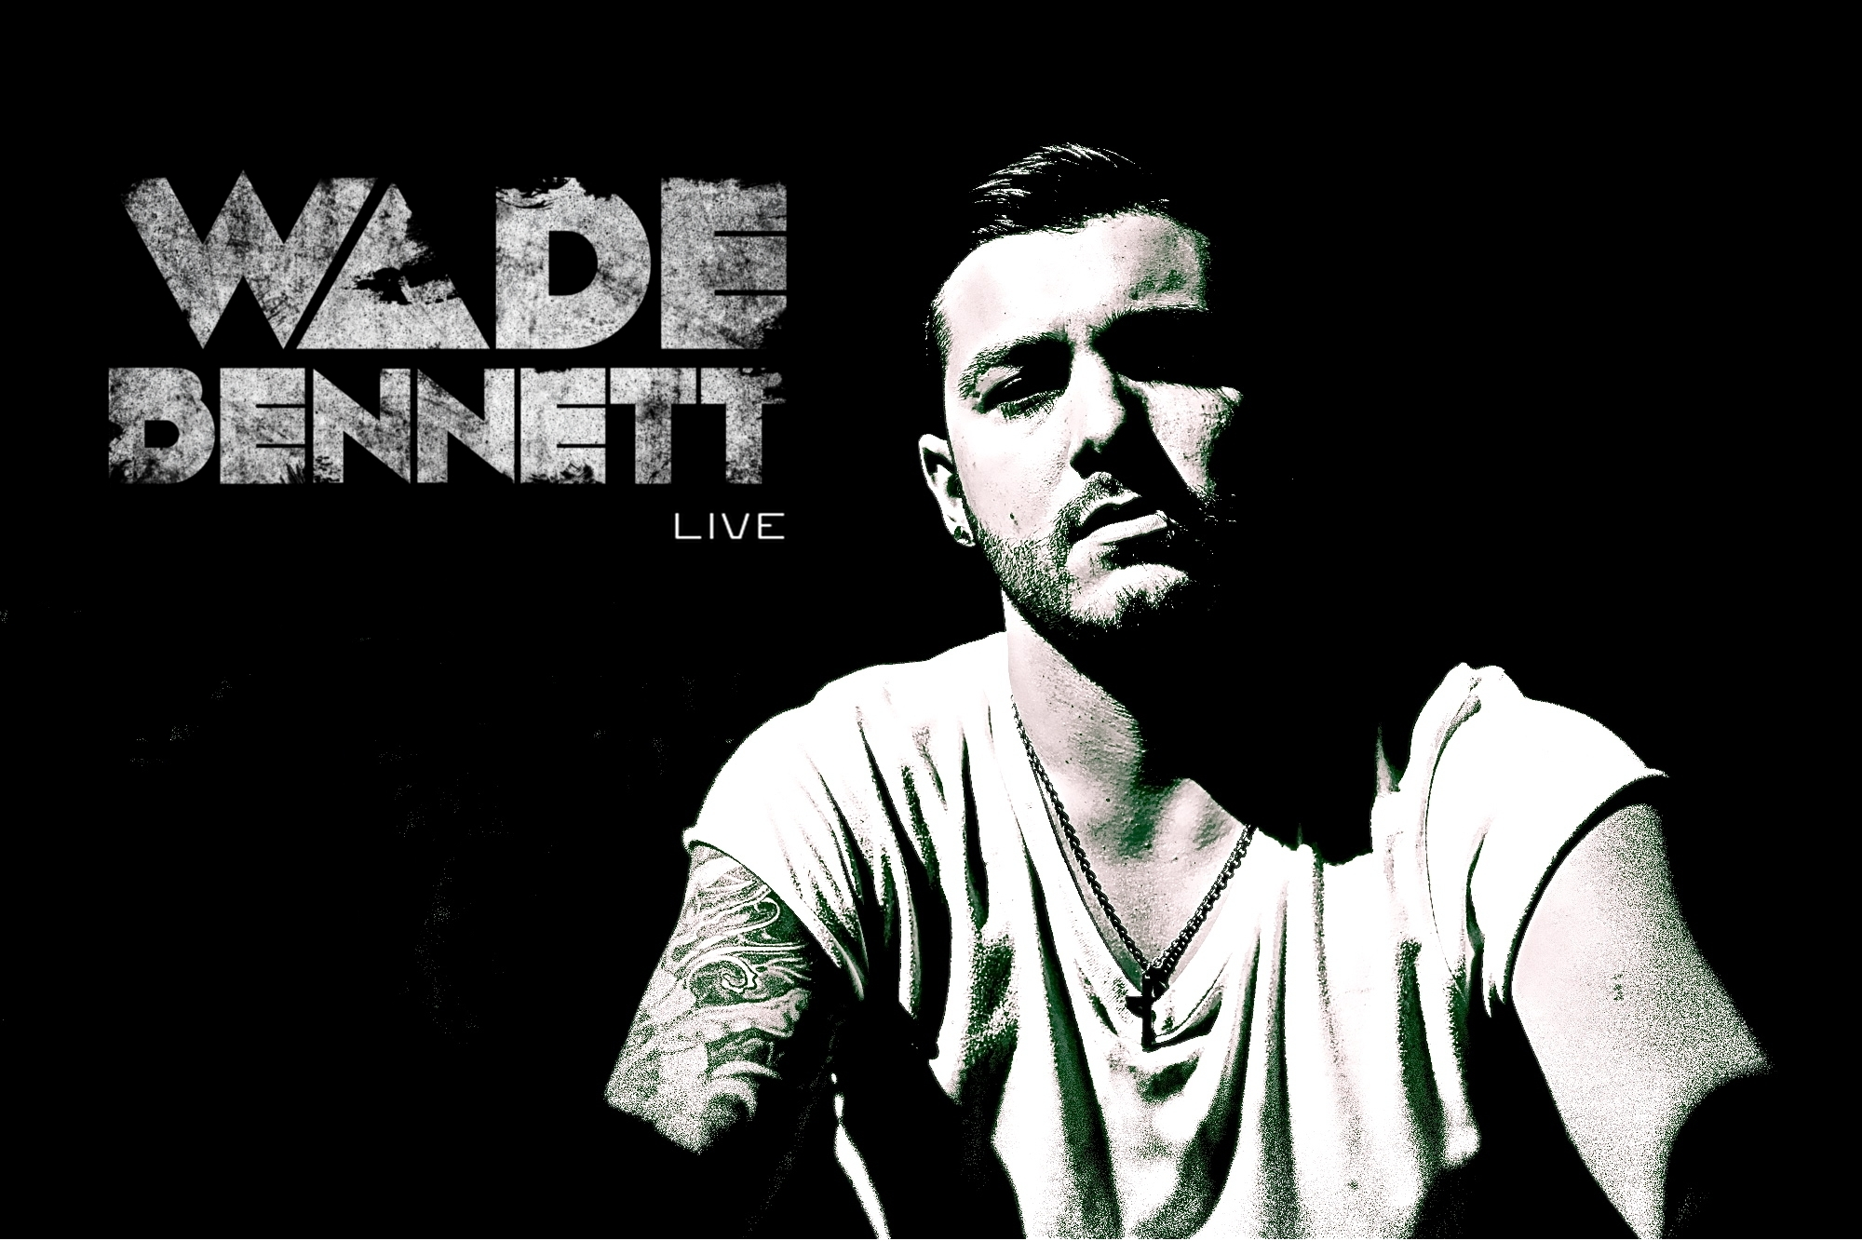

Biography

UK House and Techno Producer Wade Bennett is fast becoming a face of the Uk underground dance music scene

A sound described as ambient dub techno with influences of progressive, tech house, tribal and minimal.

Gaining international support from some of his favorite Artists and Peers. Wade's productions have also received accolades from some of the biggest names In the dance music industry including the likes of Martin Gore of Depeche Mode, Sasha, Hernan Cattaneo, Laurent Garnier, Nick Warren, Dubfire, Guy J , Stephan Bodzin, Dave seaman, Marco V, sander van Doorn, Oliver Klein, Bookashade, Steve Mac, Alan Fitzpatrick. Cid inc. among many others.

Having released for many underground labels, the likes of Baroque & Televizion and sub labels under the Proton Umbrella: Lowbit records, Jetlag Digital, Liquid Grooves & Cinematique. Whilst gaining global internet and FM radio airplay, Wades focus now lies launching his own label and brand.

With performances at some of the Uk' s leading & underground venues an events. The likes of Ministry of Sound, The Opera House (O2 Academy), Bedrock, Global Gathering alongside many independent events and venues, and appearances across Europe. He is no stranger to the main stage.

Wade is currently working on his first solo album & gesturally interactive audio visual live set, Accompanied by numerous creative collaborations with up and coming electronic Artists and labels from the world over.

Producer / Performer / Remixer / Sound Designer / Lecturer

TECHNICHAL SPECIFICATION

The following equipment must be supplied by the promoter, as agreed in the contract. Failure to supply all of the below listed equipment will result in the immediate cancellation of the performance and the management will pay to the artists the full fee plus expenses. If any of this specified items are not available, please contact bookings@wadebennett.co.uk and provide them with a list of alternative equipment.

ARTIST WILL PROVIDE

Mac book pro
Ipad
Push
Leap Motion sensor
Roland AIRA TR8 & TB3
1x gold plated Stereo Line Cable to connect direct to a channel on mixer
Uk power adapters

PROMOTOR TO PROVIDE

1x Pioneer Mixer ( DJM800, 1000, or Nexus 2000)

2X High Quality booth monitors

Booth 1x Table at least 80cm in Height and 2metres wide for Artist setup

Booth 1x Table at least 80 cm in height for Artist Drinks belongings and spare equipment bag.

Access to power to plug Uk 5 way Power Adapter

The promoter and venue must allow at least 1hour before venue opening for wade and the in house sound engineer to perform a sound check.

If space is limited in the booth, please remove turntables and have turntables lids available to provide extra space for Wade Bennett’s equipment.

Producer / Performer / Remixer / Sound Designer / Lecturer

ARTWORK

Here are the artwork instructions for Wade Bennett. Highlighted in the terms of the Artist/Promoter Agreement included, please be aware that ALL artwork, flyers and ads MUST be approved prior to any electronic or physical distribution. Failure to comply with this provision by you or anyone hired by you will result in a fine and/or cancellation of the event

The show shall be presented as Wade Bennett.

The placement and typeface used in all media shall be at least as large and as prominent as the billing for any other artist appearing at the same venue or whose name is featured on the same advertisement, handbill or poster. All web addresses must be in a font size no smaller than the address of any other act or DJ on the same bill.

All flyers and posters shall also feature:

1x photo of Wade Bennett

1x of Wade Bennett’s Logos provided

x1 URL www.wadebennett.co.uk

VISUALS

All visual effects during the artist ́s performance, at least at the opening and closing, must also feature the provided VJ loops for Wade Bennett’s Logos.

In house Visual artist to be provided with the artist logo animations to be
Presented during Wade Bennett’s set.

In order to make a booking, please fill in the form an save the word doc with a reference to your self in the title
For Uk & International bookings please send your booking request form to Heidi @

bookings@wadebennett.co.uk

Producer / Performer / Remixer / Sound Designer / Lecturer

PERFORMANCE BOOKING FORM

Your Details

Your name:

Company name:

Full Address:

Telephone number:

Email:

VENUE

Venue Name:

Venue Address:

Name of Club Night:

Venue Telephone Number:

Venue Capacity:

Number of rooms:

Nearest Airport:

Club Opening Hours:

Door charge:

Technical Specification: (Sound system, Mixers Etc)

Producer / Performer / Remixer / Sound Designer / Lecturer

EVENT

Date of event:

Frequency of events (yes or no)

Daily:

Weekly:

Monthly:

Other: (please specify)

Which Artist or DJ’s have you booked before?

What artists/DJ’s do you have booked for the future?

Who else is booked for the event?

Booking Fee offer:

Producer / Performer / Remixer / Sound Designer / Lecturer

MEDIA & ADVERTISMENT

Local magazine Contact details:

Press company contact details:

Do you have sponsorship? (Yes or no)

If yes please give details:

What Promotion do you have arranged for the event? E.g. flyers, radio, ads etc

Any other details you wish to add:

For Uk & International bookings please send your booking request form to Heidi

@ bookings@wadebennett.co.uk

Thank you for your booking request.

